Fidencio Yzaguirre III

Adam Carr

Austin Briggs

CS 2336.001

Input and Output

Or the input for the project we had four test case files; testcase1.txt, testcase2.txt, testcase3.txt, testcase4.txt. The files testcase2.txt and testcase4.txt all had invalid inputs while testcase1.txt and testcase3.txt had valid inputs.

For testcase2.txt and testcase4.txt here were the outputs.

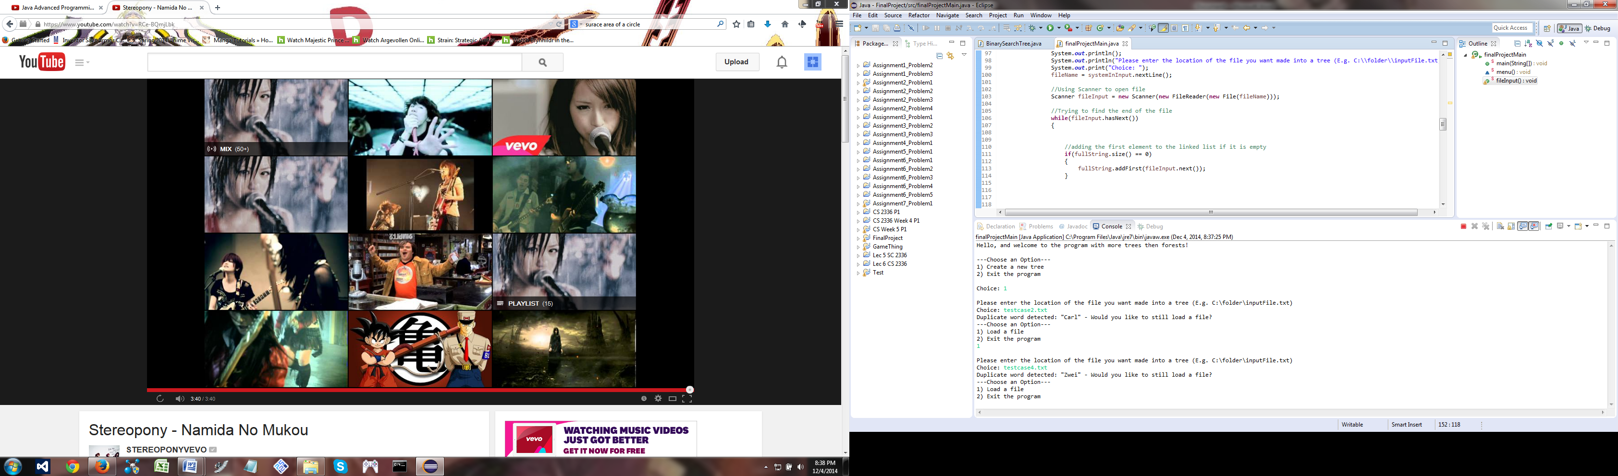

This output was expected since both files were invalid due to having the same string twice.

For testcase1.txt and testcase3.txt here are the respective outputs.

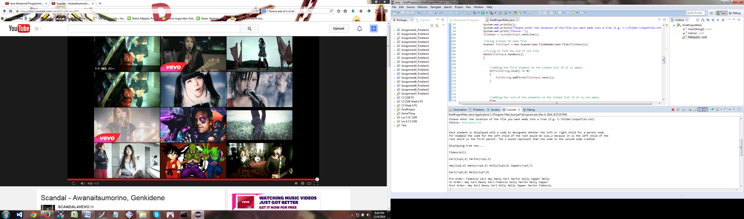

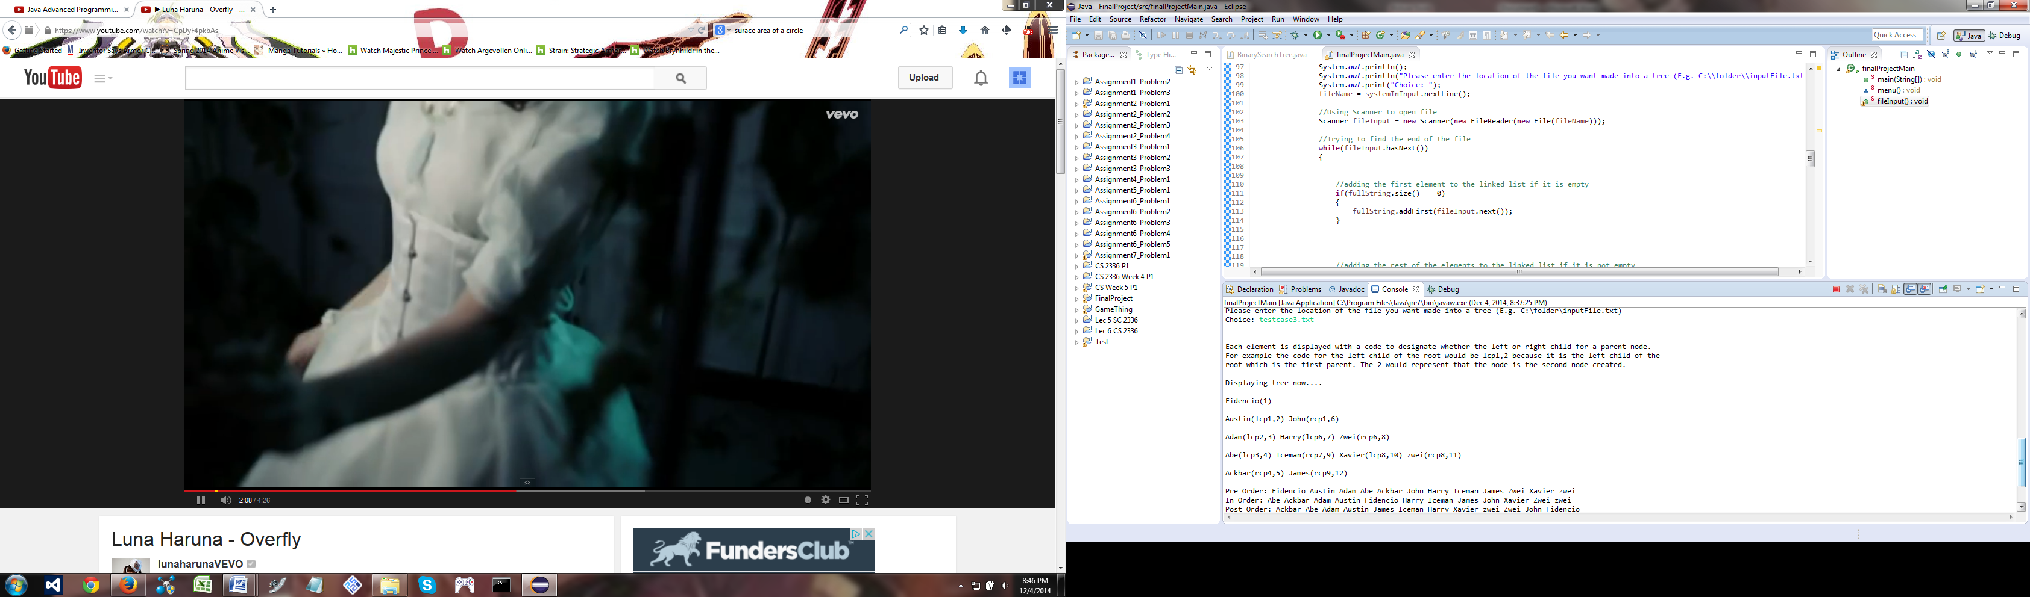

This output was as expected. The trees were properly displayed and the traversal methods were also immediately displayed to the user.

In case the file does not exist this is what happens.

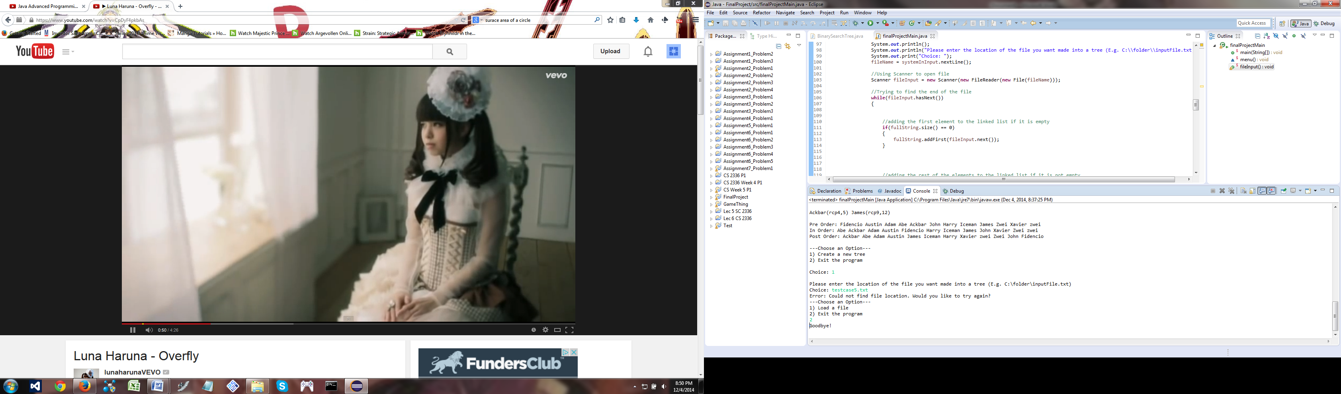

For the output files each tree’s results are appended to the file if it exists.

This is what is in the inorder.out file.



This is what is in the postorder.out



This is what is in the preorder.out

